

**Green University of Bangladesh**

**Department of Computer Science and Engineering (CSE)**

**Faculty of Sciences and Engineering**

**Semester: (Spring, Year:2021), B.Sc. in CSE (Day/Eve)**

**Course Title: Structured Programming Lab**

**Course Code: 104 Section:DD**

**Lab Project Name: Login From In C Program**

**Student Details**

| **Name** | | **ID** |
| --- | --- | --- |
| **1.** | **Tasnim Ahmed Tapoy** | **213902111** |
|  |  |  |
|  |  |  |

**Submission Date: 15 May 2022**

**Course Teacher’s Name: Md. Sultanul Islam Ovi**

**[For Teachers use only: Don’t Write Anything inside this box]**

| **Lab Project Status**  **Marks: ………………………………… Signature: .....................**  **Comments: .............................................. Date: ..............................** |
| --- |

Table of Contents

**Chapter 1 Introduction**

**1.1 Introduction**

**1.2 Design Goals**

**Chapter 2 Implementation**

**2.1 Design / Development / Implementation**

**2.2 Code**

**Chapter 3 Performance Evaluation**

**3.1 Output**

**Chapter 4 Conclusion**

**4.1 Practical Implications**

**Chapter 5 References**

# Chapter 1 Introduction

## Introduction

At present we live in a world where everyone has their own company or website. So that they are dependent websites online. If you open a company or business in online you must have a website if your workers or user come on your website you must entry their data so that you wants to data from there for that you need login from.

## Design Goals/Objective

Login From means you take data from users and you resque your website from DDS(De Dose Attack). Because when you build a big company you see automatic you make enemy. If you wants to save this enemy attack you must sequer your website from there if you make a login or sinup page your enemy won't attack in your website. Because Robot can't attack for login page. So that we make and need must use that on website.

# Chapter 2

**Implementation**

**2.1 Design / Development / Implementation**

**ALGORITHM :**

**STEP 1 :Start;**

**STEP 2 : declare some header file;**

**STEP 3 : define value;**

**STEP 4 : function define;**

**STEP 5 : make structure;**

**STEP 6 : file pointer use;**

**STEP 7 : use xy coordinates;**

**STEP 8 : call a function which has not return value that is call void function ;**

**STEP 9 : start while loop;**

**STEP 10 : use gotoxy function;**

**STEP 11 : print and scanf use;**

**STEP 12 : ch asinine getch;**

**STEP 13 : switch function use;**

**STEP 14 : case 1 use for login**

**STEP 15 : F1 for login**

**STEP 16 : case 2 which F2 for sinup**

**STEP 17 : Esc for exit that is case 3**

**STEP 18 : now call login function;**

**STEP 19 : declare username,pass,chkp,chku;**

**STEP 20 :file use fp=fopen("record.bin","rb");**

**STEP 21 : take username and password;**

**STEP 22 : use for loop for take password;**

**STEP 23 : compare password and username with**

**our data**

**STEP 24 : fread function use to go file pointer and check**

**STEP 25 : now call sinup function;**

**STEP 26 : record.bn is a file where we asinine all value which**

**user give us for sinup;**

**STEP 27 : for loop use for take password;**

**STEP 28 : if user press esc oure program turminet;**

**STEP 29 : end;**

**2.2 Code**

| **#include<stdio.h>**  **#include<conio.h>**  **#include<stdlib.h>**  **#include<windows.h>**  **#define ESC 27**  **#define F1 59**  **#define F2 60**  **void signup(void);**  **void login(void);**  **struct**  **{**  **char password[20];**  **char username[20];**  **} s;**  **FILE *fp;**  **COORD coord= {0,0};**  **void gotoxy(int x,int y)**  **{**  **coord.X=x;**  **coord.Y=y;**  **SetConsoleCursorPosition(GetStdHandle(STD_OUTPUT_HANDLE),coord);**  **}**  **void main()**  **{**  **int ch;**  **while(1)**  **{**  **system ("cls");**  **gotoxy(20,5);**  **printf("____Programming Made Easy_____");**  **gotoxy(28,7);**  **printf("Yours Welcome Here...........");**  **gotoxy(28,9);**  **printf("Press F1 For Login");**  **gotoxy(28,11);**  **printf("Press F2 For Signup");**  **gotoxy(28,13);**  **printf("Press ESC For Exit");**  **gotoxy(20,15);**  **printf("___********_____\n");**  **getch();**  **ch=getch();**  **switch(ch)**  **{**  **case F1:**  **system ("cls");**  **gotoxy(10,14);**  **for(int i=0; i<40; i++)**  **{**  **printf("_");**  **//fordelay(40);**  **}**  **login();**  **break;**  **case F2:**  **system ("cls");**  **gotoxy(10,14);**  **for(int i=0; i<40; i++)**  **{**  **printf("_");**  **// fordelay(40);**  **}**  **signup();**  **break;**  **case ESC:**  **exit(0);**  **break;**  **}**  **}**  **getch();**  **}**  **void login()**  **{**  **int c,i;**  **char username[20];**  **char pass[20];**  **char chkp;**  **char chku;**  **system ("cls");**  **gotoxy(23,5);**  **printf("_____Login Zone___");**  **gotoxy(23,7);**  **fp=fopen("record.bin","rb");**  **printf("Enter UserName :");**  **gets(username);**  **gotoxy(23,9);**  **printf("Enter PassWord :");**  **for(int i=0; c=getch()!=13; i++)**  **{**  **pass[i]=c;**  **printf("*");**  **}**  **pass[i]='\0';**  **while(!feof(fp))**  **{**  **fread(&s,sizeof(s),1,fp);**  **chku=strcmp(username,s.username);**  **chkp=strcmp(pass,s.password);**  **if(chku==0&&chkp!=0)**  **{**  **printf("Invalid password!!!!!!!!!!!!");**  **break;**  **}**  **else if(chku!=0&&chkp==0)**  **{**  **printf("\n\tInvalid Username!!!!!!!!");**  **break;**  **}**  **else if(chku==0&&chkp==0)**  **{**  **system ("cls");**  **gotoxy(20,10);**  **printf("_Hello %s Welcome Here_ ",s.username);**  **break;**  **}**  **}**  **getch();**  **}**  **void signup()**  **{**  **char c;**  **fp=fopen("record.bin","ab");**  **system ("cls");**  **gotoxy(23,5);**  **printf("_____SignUp Zone____");**  **gotoxy(23,7);**  **printf("Set UserName : ");**  **gets(s.username);**  **gotoxy(23,9);**  **printf("Set Password : ");**  **for(int i=0; c=getche()!=13; i++)**  **{**  **s.password[i]=c;**  **}**  **gotoxy(23,11);**  **printf("Press Enter to continue.........");**  **if(getch()==13)**  **{**  **fwrite(&s,sizeof(s),1,fp);**  **gotoxy(23,13);**  **cprintf("\n Informations Saved....");**  **}**  **else**  **return;**  **fclose(fp);**  **getch();**  **}** |
| --- |

# 

# 

# 

# 

# 

# 

# Chapter 3

## Output

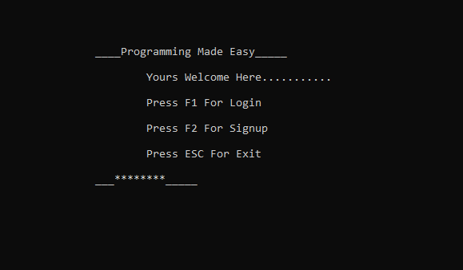

**Welcome Page**

**Select which you want**

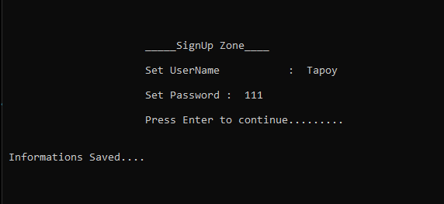

**We Press F2**

**That's SinUp Zone**

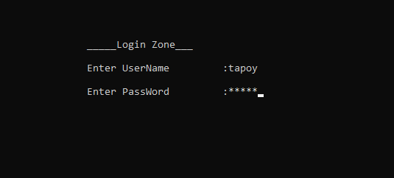

**We Press F1**

**Thats Login Zone**

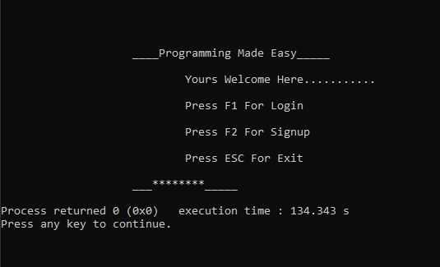

**If We Press Esc**

**Our Program Terminet**

# Chapter 4 Conclusion

## Practical Implications

**Login From and Sinup From every website must be used because that looks nice and helps website owners to protect from hackers, robots,dds attack. And also need for that user security.**

# References

1. **Empty**

**There is no copy things so that no need to give any reference**